

National Econimic analysis

of

BRAZIL



November 4, 2019

Jarrod Miller, Zac Miller, Megan Jones, Asya Asenova



1. **Introduction:**

Located on the eastern coast of South America, Brazil occupies nearly half of the continent's landmass. The official language of Brazil is Portuguese, which is spoken by 97.9% of the population as their primary language (World Atlas, 2018). In terms of GDP, Brazil is ranked 9th globally and is predicted to have a nominal GDP of approximately 2.0 trillion in 2019 (Focus Economics, 2018). The economy of Brazil is best described as a mixed economy. It is mainly based on a free market (capitalist) economy, but also possesses a significant amount of government control. Currently, Brazil is still categorized as a developing country. To be considered a developed country, the economy must have a GDP per capita of $12,000. As of 2018, Brazil only had a GDP per capita of $8,921 (Macrotrends). Among the members of the Organization for Economic Cooperation and Development (OECD), of which Brazil is a part of, Brazil has the highest number of state-owned enterprises (SOE's) according to a 2018 article from Forbes. While the economy itself follows the laws of supply and demand, the corporations within Brazil are highly regulated by the federal government. Overall, the government is highly involved with the economy of Brazil, and many attribute this involvement as a significant contributor to many of the deficiencies in the performance of their economy. This project evaluates Brazil's past economic performance to predict whether or not this economy improves growth.

1. **Short-run Growth indicators:**

Despite the high involvement of the government, from 2014 to 2018, Brazil's GDP has been declining, as shown in Table 1. The decline was at its peak between 2015 and 2016. During that time, the GDP growth was in the negative spectrum varying between -3.3% and -3.5%. In 2017 and 2018, the GDP annual growth became positive at an average of 1% growth. Table 1 captures the data of Brazil's GDP in more detail. The most significant gain was made between 2016 and 2017.When comparing Brazil's GDP amongst the average across the world, it appears to be reacting normally. While initially showing above average in 2014, it has been consistently slightly below.

Figure 1: Sum of GDP (2014 to 2018) Figure 2: Annual GDP growth of Brazil (2014 to 2018)

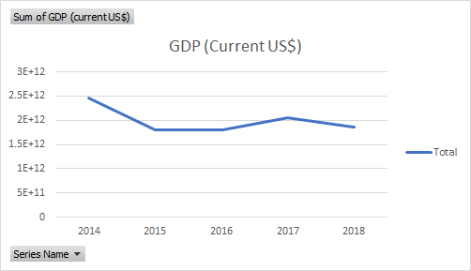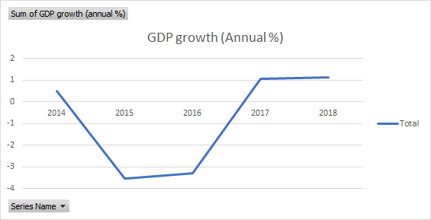

To have a clear understanding of where Brazil is standing in terms of GDP, Figure 3 shows the sum of Brazil's GDP, the World's, and the United States. When comparing Brazil’s GDP to the US GDP, it’s clear that Brazil is still in development. When comparing it to the World's GDP on average, both are running at about the same rate.

Figure 3: GDP per Capital between Brazil, the World, and the United States

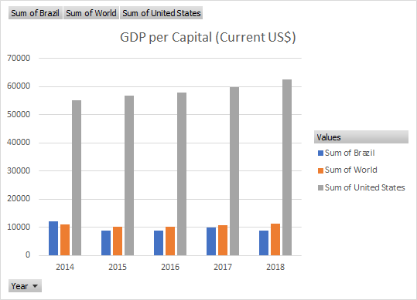  
  
 Gross National Income (GNI) plays a significant role in Brazil’s development. Annual GNI growth has been in the negative spectrum from 2014 until 2017. In 2018 Brazil’s GNI moved in a positive direction with an increase of 5.42% annual growth for the year. Just like with GDP, we can compare the sum Brazil's GNI to the World’s and the US GNI and make a couple of conclusions. The sum of Brazil's GNI, on average, runs slightly above the sum of the World's GNI. Thus we can conclude that in comparison to the world, Brazil is doing better than other developing countries. When comparing the US GNI, however, Brazil is still a developing country. Figure 4 illustrates the relationship between Brazil, the World, and the US concerning

Figure 4. GNI per Capital between Brazil, the World, and the United States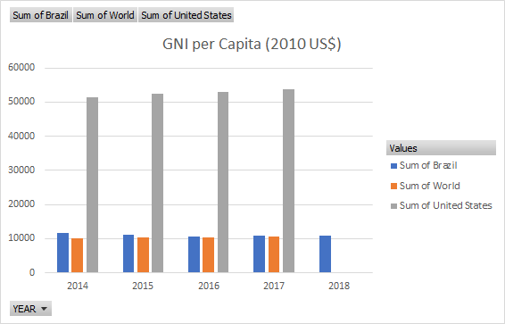

Unemployment is a significant factor that also needs to be taken into consideration when following economic growth patterns of any country. Level of education is a significant factor that helps determine unemployment. Unemployment in Brazil has grown regardless of education level. Figure 5 shows patterns of Unemployment in Brazil based on education lever for the past five years. For advanced educated individuals, the unemployment has nearly tripled since 2014, thus indicating pressure on the professional sector. Primary education is closely aligned with the total labor unemployment rate suggesting Brazil's economy is mostly made of people with primary education.

Figure 5. Unemployment % by Education Level (2014 to 2018)

Figure 6: Graph presentation of inflation percentage of Brazil (2014 to 2018)

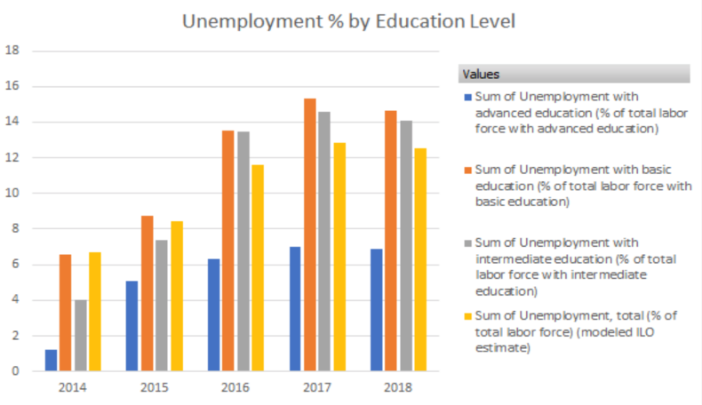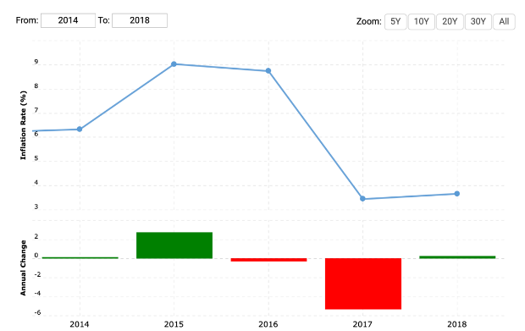

As a result of high unemployment rates, inflation rates in Brazil are also fluctuating. Inflation is measured by the consumer price index and reflects the annual percentage change based on purchases of goods and services. Inflation runs parallel with unemployment rates. Thus when unemployment is high, inflation rates will also be high. Table 2 and Figure 7 provide the numerical and visual pattern of inflation rates for Brazil for the past five years.

1. **Analysis of short-run policy conditions**

The monetary policy of Brazil is controlled by the Central Bank of Brazil. The Brazilian Real is the official currency of Brazil. The Central Bank of Brazil is the authority responsible for any issue of money. For the past five years the money supply of Brazil has been progressively increasing. The money supply is monitored on a monthly base.

Figure 7: Money Supply of Brazil for the last 5 years (2014 to 2018)

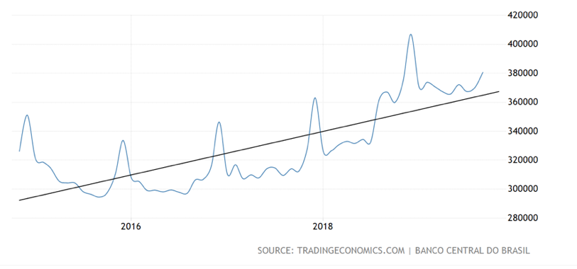

Between 2014 and 2018 Brazil’s interest rates have been fluctuating a lot. Between 2014 and 2015 interest rates were increasing until they hit a plateau in 2016 and locked up at about 15%. After 2016 interest rates started dropping significantly to about 5% and they are continuing to take a cut every month. The federal bank of Brazil is continuing to drop interest rates hoping that that will help the economy.

Figure 8: Interest rates from 2014 to 2018

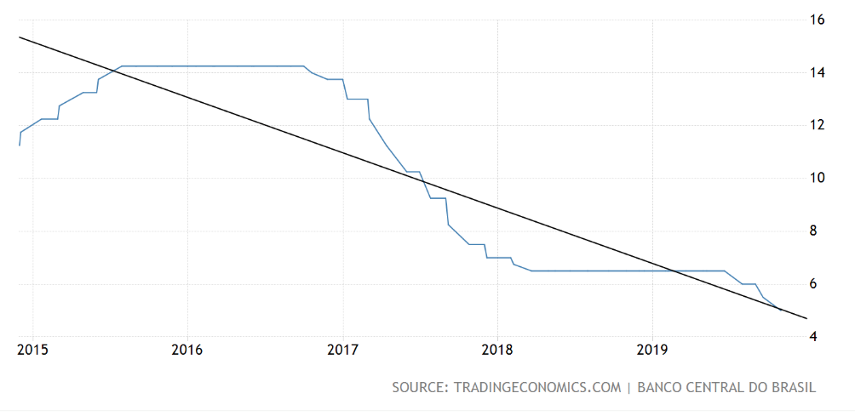

The fiscal Policy of Brazil involves all government spending activities, government debt, as well as taxes. Government spending in Brazil has been increasing drastically within the past five years.

Figure 9: Government Spending in Brazil 2014 to 2018

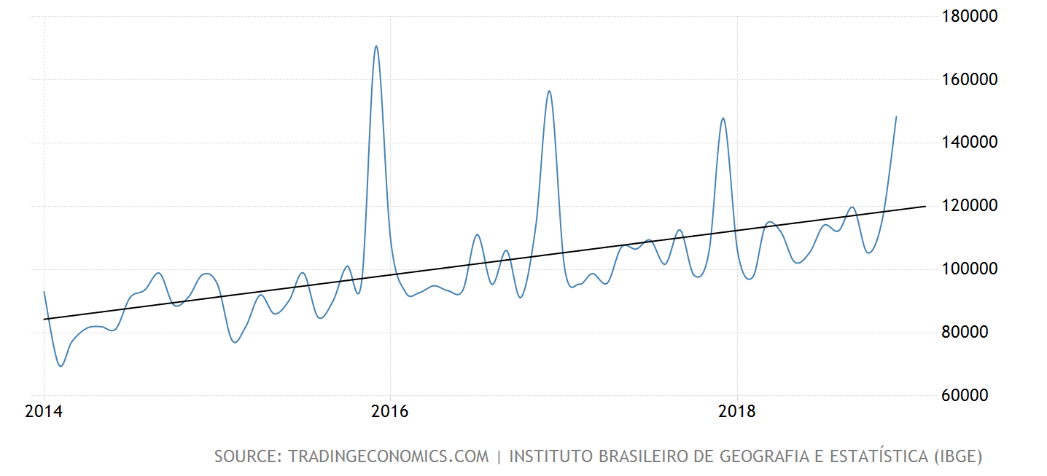

Some government spending encourages economic growth, however when government spending continues to increase a deficit is formed. Between 2014 and 2018 the deficit of Brazil reached 10.2% in 2015 and it has decreased by about 3% in 2018.

Figure 7: Deficit trend in Brazil (2014 to 2018)

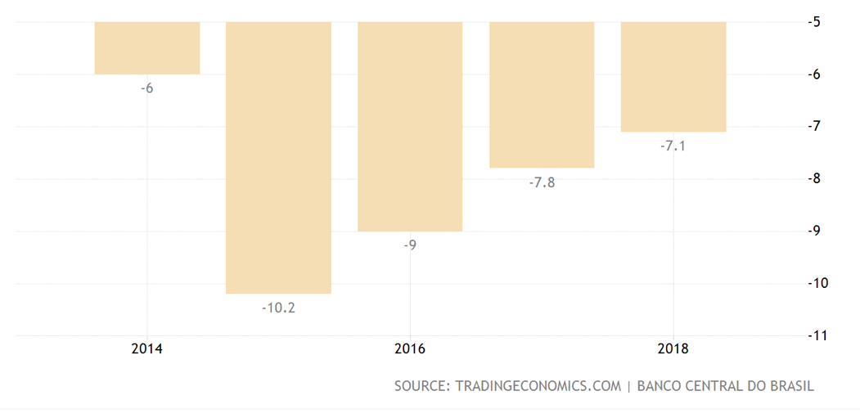

The Domestic debt of the country has been also increasing. Varying from 27000000 BRL in 2014 to about 48000000 BRL in 2018, Brazil’s domestic debt continues to follow an increasing trend to about 55000000 BRL.

Figure 10: Domestic Dept of Brazil as a percentage of GDP

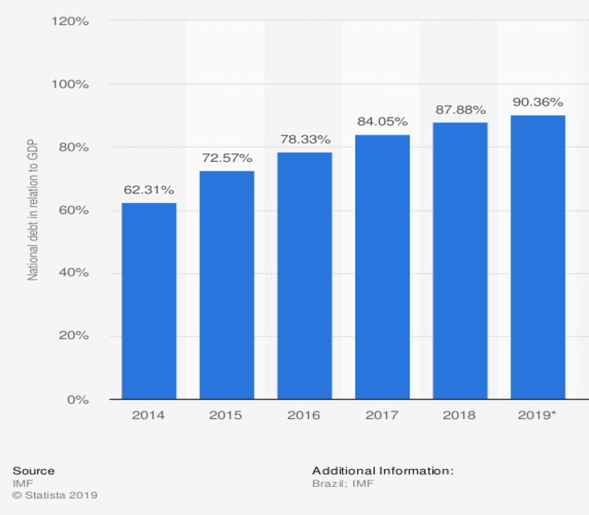

Individual income tax for Brazil is pretty high. Everyone is taxed the max of 27.5%. The Brazilian fiscal year stretches from Jan 1 to Dec 31. People are taxed on a monthly basis. Out of these taxes the Brazilian government covers education expenses, Brazilian Private Pension Plan which covers up to 12% of the gross income, Social Security rates, and medical expenses. Donations, school fees and medical expenses sum up to a maximum 20% of the global annual income.

Brazil also has Corporation tax. This tax applies to any businesses that make up to 1.3 million a year. The corporate tax is in place in lieu of federal, state and municipal taxes such as federal corporate tax, federal excise tax, social contribution on net income, federal payroll taxes, state taxes on goods and services and municipal services tax.

Unlike European countries, Brazil does not have a VAT. Instead, Brazil adds a state and a federal tax to all goods and services. The value added sales and services tax (ICMS - state tax) and excise tax (IPI – federal tax). The ICMS tax varies within different regions of the country from 17% to 19% and the IPI tax is on average about 10%.

Consumer spending is following a down sloping trend. Consumers spending really dropped between 2015 and 2016. In 2017 and 2018 it has increased but it is still following a decreasing slope pattern.

Figure 8: Consumer spending (2014 to 2018)

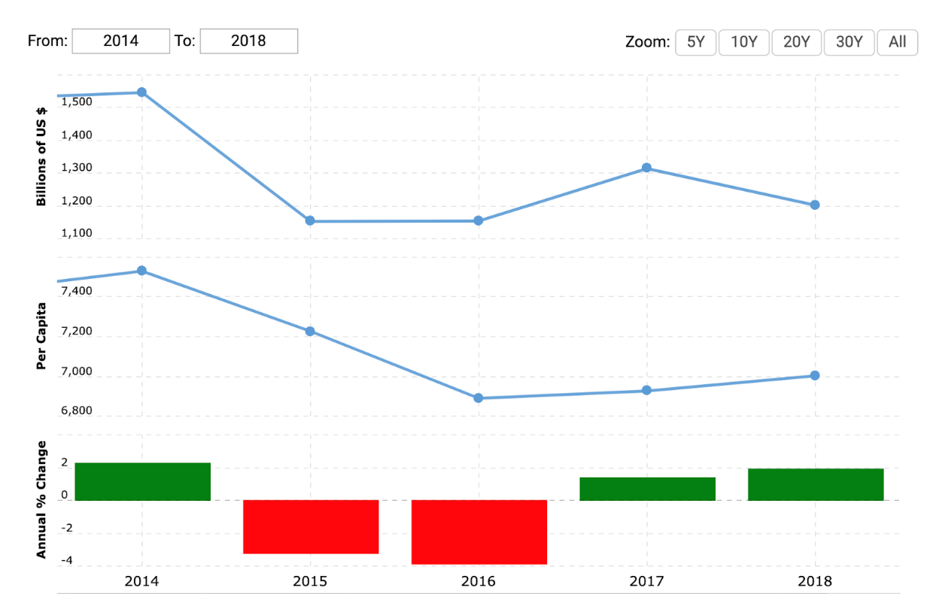

1. **Analysis of long-run growth conditions**

Using data from the past twenty years and taking and average between the first and second decade we can also analyze the long run growth of Brazil. Interpreting factors like GDP, GNI per capita, Savings, Investment, Population Growth, Measures of Human Capital as well as measures of innovation and technological changes we can determine long run growth conditions of Brazil.

The economy of Brazil is best defined as a mixed economy. Mainly based on a free market economy, Brazil also contains strong influence of government control. Currently, Brazil is still categorized as a developing country. To be considered a developed country, the economy must have a GDP per capita of $12,000. As of 2018, Brazil only had a GDP per capita of $8,921 (Macrotrends).

Figure 9: Growth rate (A) and GDP per Capita (B) for the last 20 years

A).

B).

The growth rate of the economy for the past twenty years has been showing some drastic high and low turns. Overall the growth rate of the country has been very slowly progressing. In typical developing country growth rate is more rapid, however in Brazil’s case the growth rate shows slow progress due to the drastic high and low peaks.

The long term per Capita graph has shown an overall positive trend since 2000. Both graphs reflect the recession of Brazil in 2014 and we can clearly notice it both in the growth rate of GDP as well as the GDP per capita graphs.

The trend for positive growth in Brazil began in the 2000s and then it stopped when the country was hit with the recession in 2014.

The gross national income has been following very similar trend as with GDP.

Figure 10. GNI of Brazil for the past 20 years

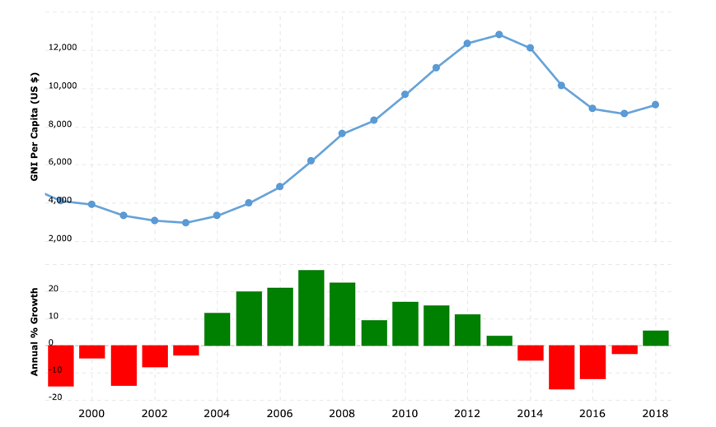

Even though Brazil was hosting many world events in 2014, the country was still seen as not meeting the needs of the people simply because of the recession.

Despite the fact that the country has not be significantly growing ss a metrics, savings has been pretty steady over time.

Figure 11. Savings trends of Brazil for the past 20 years

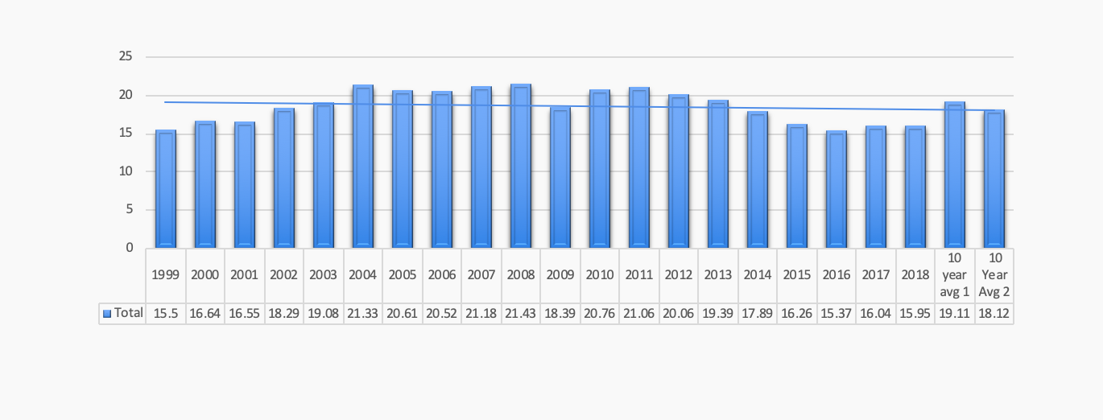

At the end of the graph there are two average metrics indicating the first and second decade. The first covers 1998 -2009 and the second covers 2010 - 2018. The second average is on par with the trend line as recent years are starting to catch up with the previous period of growth.

Investment through the years has also remained steady for the most part. Recent years investment has been falling below average however the 10 year averages are on par with the overall trend.

Figure 12. Investment trends of Brazil for the past 20 years.

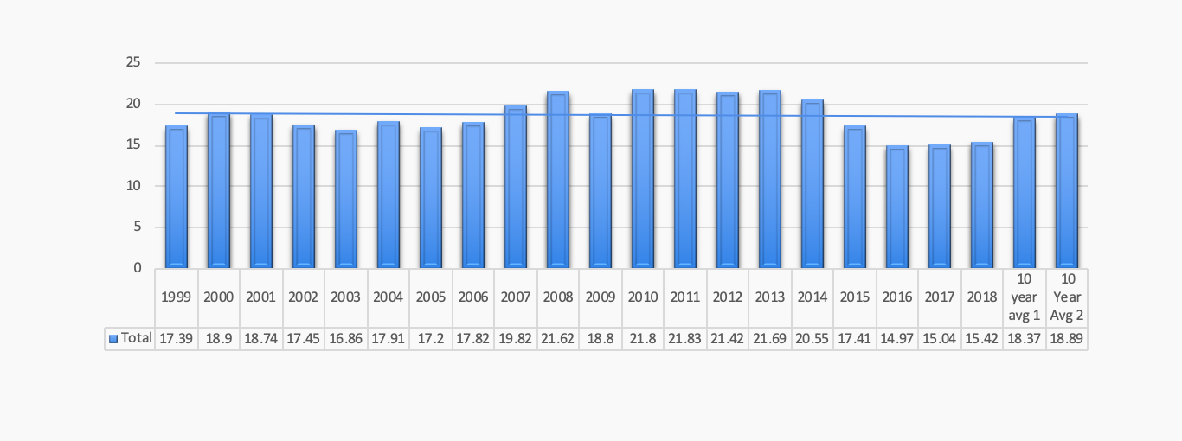

Population growth of Brazil has been slowing declining. Decline of population is typically an indicator of developed countries, however despite the fact that Brazil is still considered to be a developing country the population growth is declining instead of increasing. Figure 13 shows a visual representation of population growth for the past twenty years.

Figure 13. Population growth pattern of Brazil for the past 20 years

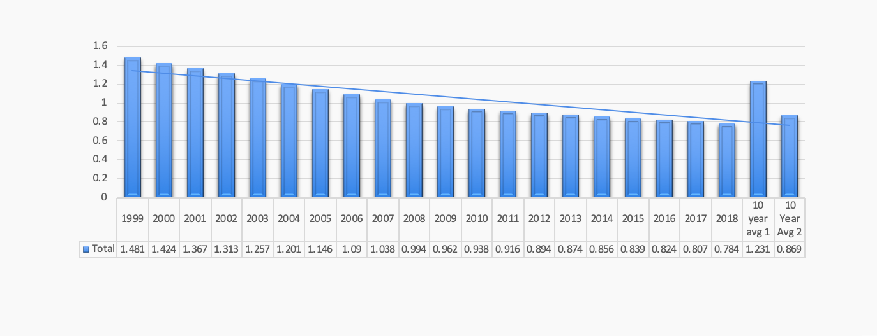

In order to interpret Human Capital advance education was analyzed, even though research in the previous section indicated that unemployment was lowest amongst advanced education group of individuals. Through the unrest at various periods Advanced Education remains relatively unchanged.

Figure 14: Education trends of brazil for the past 20 years

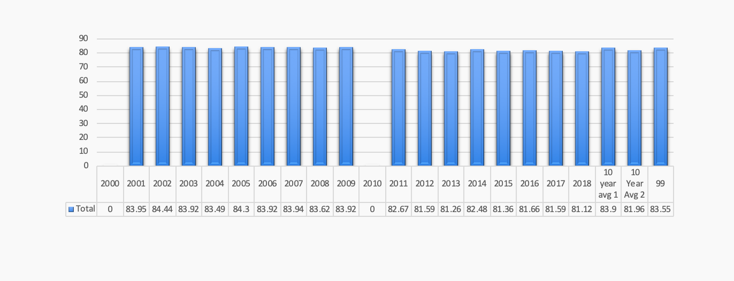

Innovation and Technological Growth was the indicator that best matched the periods of unrest or uncertainty with the government. The initial rise with the Lula leadership in 2003. With the down ward trends signaling the investigations and news of bribery amongst the cabinet. Finally leading to newly elected leadership in 2018.

Figure 15. Measure of Innovation and Technological Growth for Brazil (20 years)

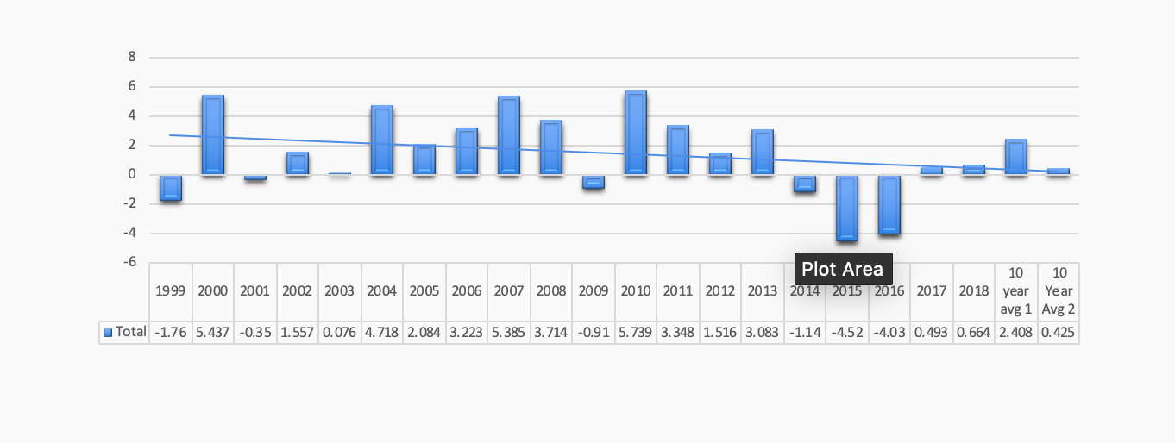

5.Balance of Payments analysis and evaluation of sovereign risk

|  |  |  |  |  |  |  |  |  |  |
| --- | --- | --- | --- | --- | --- | --- | --- | --- | --- |
| **Periods** | **S** | **I** | **T** | **G** | **X** | **M** | **CA** | **X-M** | **FDI** |
| 1999-2003 | 17.212 | 17.868 | 14.493 | 19.356 | 12.307 | 12.956 | -2.568 | -0.649 | 3.806 |
| 2004-2008 | 21.013 | 18.875 | 15.786 | 18.836 | 14.605 | 12.466 | 0.600 | 2.139 | 2.476 |
| 2009-2013 | 19.932 | 21.107 | 13.871 | 18.952 | 11.384 | 12.559 | -2.915 | -1.175 | 3.266 |
| 2014-2018 | 17.280 | 18.072 | 13.026 | 19.489 | 12.483 | 13.275 | -2.324 | -0.792 | 3.707 |

Using data from the same twenty year period as the long-run analysis we are also able to take a deep dive to do a Balance of Payments analysis. T does not include data from 2018. Overall Brazil has shown both periods of growth and decline. Shown above and in the previous section the early 2000’s were a period of growth and development. The last two periods shown above are skewed by the financial hardships of 2014. The short run has shown positive trends over time while the long run is showing relatively stable in spite of the change within each period.

|  |  |  |
| --- | --- | --- |
| **Periods** | **I-S** | **M-X** |
| 1999-2003 | 0.656 | 0.649 |
| 2004-2008 | -2.139 | -2.139 |
| 2009-2013 | 1.175 | 1.175 |
| 2014-2018 | 0.792 | 0.792 |

When comparing the exports (x) and imports (m) of goods & services that Brazil is there is a trade deficit in all periods with the exceptions on 2004-2008. Accordingly there is a net capital inflow as for those same periods. 2004-2008 was the greatest increase in GDP per Capita in addition to the improvements politically.

|  |  |  |  |  |  |  |
| --- | --- | --- | --- | --- | --- | --- |
| **Periods** | **S** | **I** | **Y** | **n** | **g** | **Y/L** |
| 1999-2003 | 17.21 | 17.87 | 2.09 | 1.37 | 0.99 | 8507.28 |
| 2004-2008 | 21.01 | 18.87 | 4.82 | 1.09 | 3.82 | 9689.05 |
| 2009-2013 | 19.93 | 21.11 | 3.26 | 0.92 | 2.56 | 11195.59 |
| 2014-2018 | 17.28 | 18.07 | 0.11 | 0.84 | -0.56 | 11230.51 |

The data from Part 4 has been reformatted above to provide an easier view of the changes in GDP, population, and technological change. Both GDP and Technological Change saw the largest advancement in the 2004-2008 period. As with other developed nations population growth begins to trend down as well.

Brazils economy from developing to emerging has ultimately hit a road block in 2014 due to the corruption and uncertainty in government. Brazil has otherwise seen a steady economy across the twenty year span. In order to make the ascension as a developed nation leadership must increase and maintain the growth it has seen.

Work Cited:

Afonso, J. R., Araújo, E. C., & Fajardo, B. G. (2016, July 28). The role of fiscal and monetary policies in the Brazilian economy: Understanding recent institutional reforms and economic changes. Retrieved from <https://www.sciencedirect.com/science/article/pii/S1062976916300527>.

Boadle, A. (2019, January 9). New Brazil government riven by divisions, policy confusion. Retrieved from <https://www.reuters.com/article/us-brazil-politics-divisions-analysis/new-brazil-government-riven-by-divisions-policy-confusion-idUSKCN1P328X>

Brazil - budget balance in relation to GDP 2024 | Statista. (2014). Retrieved October 27, 2019, from Statista website: <https://www.statista.com/statistics/270877/brazils-budget-balance-in-relation-to-gdp/>

Brazil - National debt in relation to gross domestic product (GDP) 2024. (n.d.). Retrieved from <https://www.statista.com/statistics/271041/national-debt-of-brazil-in-relation-to-gross-domestic-product-gdp/>

Brazil . (n.d.). Retrieved October 24, 2019, from <https://kids.britannica.com/students/article/Brazil/273339/283133-toc>.

Brazil Consumer Spending 1960-2019. (n.d.). Retrieved from <https://www.macrotrends.net/countries/BRA/brazil/consumer-spending>.

Brazil GDP Per Capita 1960-2019. (n.d.). Retrieved October 24, 2019, from <https://www.macrotrends.net/countries/BRA/brazil/gdp-per-capita>.

Brazil General Government Gross Debt. (n.d.). Retrieved from <https://tradingeconomics.com/brazil/government-debt>.

Brazil GNI Per Capita 1966-2019. (2019). Retrieved October 27, 2019, from Macrotrends.net website: <https://www.macrotrends.net/countries/BRA/brazil/gni-per-capita>

Brazil Government Budget. (n.d.). Retrieved from <https://tradingeconomics.com/brazil/government-budget>

Brazil Interest Rate. (n.d.). Retrieved from

Brazil Money Supply M0. (n.d.). Retrieved from <https://tradingeconomics.com/brazil/money-supply-m0>.

Chappelow, J. (2019, September 29). Centrally Planned Economy. Retrieved October 24, 2019, from <https://www.investopedia.com/terms/c/centrally-planned-economy.asp>.

nternational Monitory Fund. (2019). Retrieved October 27, 2019, from Imf.org website: <https://www.imf.org/external/datamapper/PCPIPCH@WEO/BRA?zoom=BRA&highlight=BRA>

McGeever, J. (2019, May 14). Brazil government, central bank nod to rapidly deteriorating GDP, fiscal position. Retrieved from <https://www.reuters.com/article/us-brazil-economy-growth/brazil-government-central-bank-nod-to-rapidly-deteriorating-gdp-fiscal-position-idUSKCN1SK2IR>.

Momsen, R. P., & Poppino, R. E. (2019, November 4). Brazil since 1990. Retrieved from <https://www.britannica.com/place/Brazil/Brazil-since-1990>

Pariona, Ameber. (2018, August 7). What Languages are Spoken in Brazil? Retrieved from <https://www.worldatlas.com/articles/what-languages-are-spoken-in-brazil.html>

Roberts, J., & Castro, G. de A. (2018, May 29). Big Government Has Crushed Economic Freedom in Brazil. Retrieved October 24, 2019, from <https://www.heritage.org/economic-and-property-rights/report/big-government-has-crushed-economic-freedom-brazil>.

Taxes in Brazil - International Living Countries. (n.d.). Retrieved from <https://internationalliving.com/countries/brazil/taxes/>

The World's Top 10 Largest Economies. (2018, November 8). Retrieved October 25, 2019, from <https://www.focus-economics.com/blog/the-largest-economies-in-the-world>.

Top 25 Developed and Developing Countries. (2019, August 2). Retrieved October 24, 2019, from <https://www.investopedia.com/updates/top-developing-countries/#brazil>.

Whittemore, J. (n.d.). Traditional, Command & Market Economies of Central & South America Video. Retrieved October 24, 2019, from <https://study.com/academy/lesson/traditional-command-market-economies-of-central-south-america.html>.

World Development Indicators | DataBank. (2015). Retrieved October 23, 2019, from Worldbank.org website: <http://databank.worldbank.org/data/reports.aspx?source=world-development-indicators>